01: Write a program to print the characters from 'A' to 'Z' using a for loop.

02:Write a program that takes a string as input and prints the first n characters of the string using a loop.

03: Write a program that takes a string as input and prints the last n characters of the string using a loop.

04: Suppose you have a rectangular cake that has already been cut twice, resulting in three rectangular pieces. Using a simple loop in C++, how can you make a third cut to add a fourth rectangular piece to the cake? You can assume that the first two cuts have already been made parallel to one of the sides of the cake, and that the third cut should also be made parallel to the same side. Your goal is to add a fourth piece that is of equal width to the existing pieces.

Write a program that uses a loop to make the third cut, and outputs the dimensions of the four resulting pieces.

05: Write a program that takes a string as input and prints the first half of the string using a loop.

06: Write a computer program that prints the following sequence up to n-terms where ‘n’ is taken as input from the user.

07: Write a computer program to calculate the sum of numbers (10 numbers max). If the user enters a negative number, the loop terminates using the break statement.

08: Write a C++ Program to print Capital and Small alphabets using Loops.

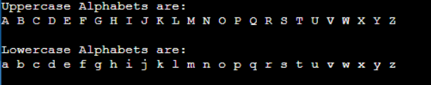

09: Write a program that takes a string as input and removes all vowels from the string using a loop.

10: Suppose you have a piece of paper that is 8.5 inches wide and 11 inches long. You want to cut the paper into smaller pieces that are all the same size. Using a simple loop in C++, how can you make 4 cuts to create 16 smaller pieces of paper that are each 2.125 inches wide and 2.75 inches long?

Write a program that uses a loop to make the cuts, and outputs the dimensions of each of the 16 resulting pieces of paper.